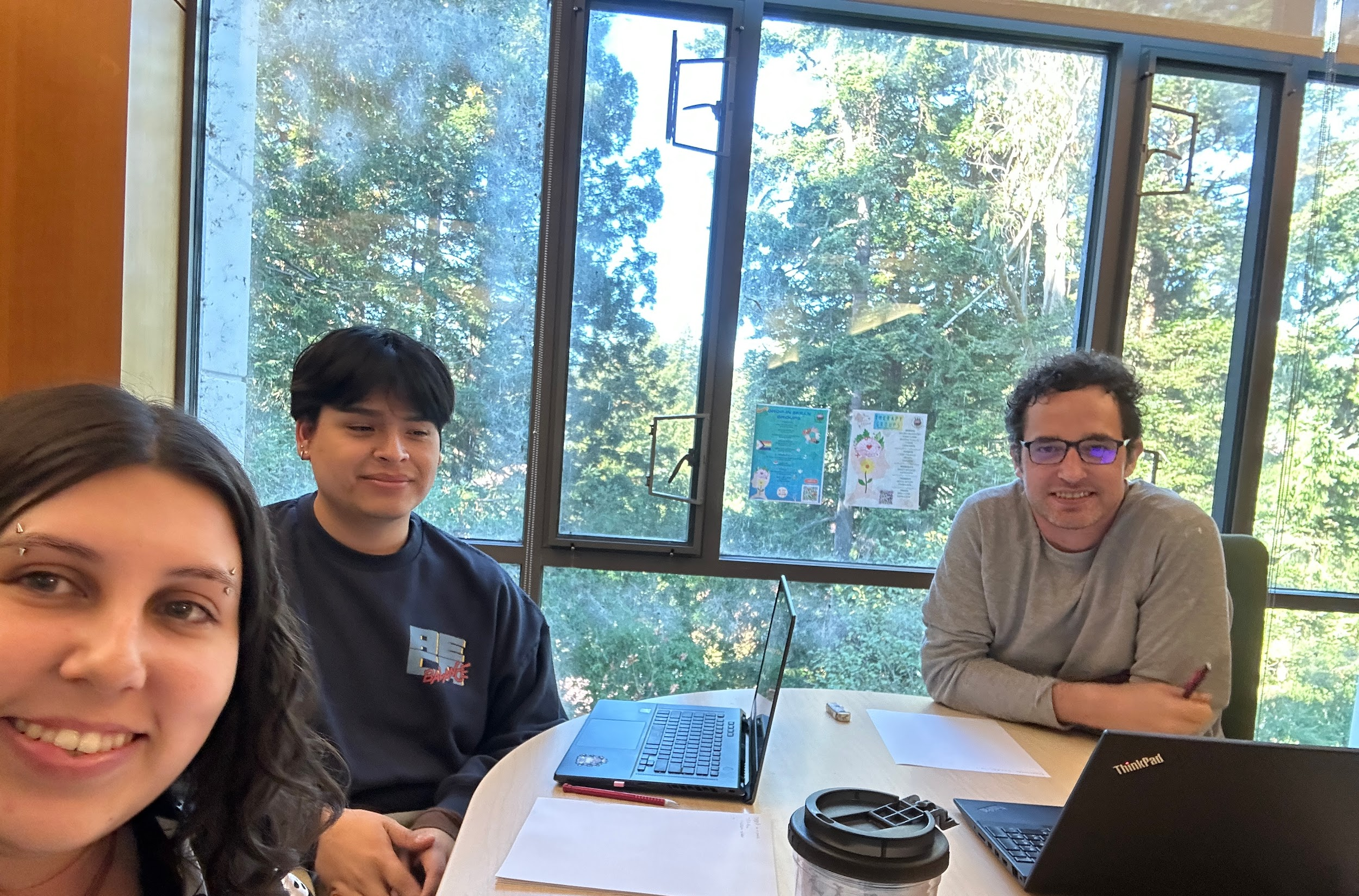

#+title: Exam 1 Study group

\* members

+ Juliana

+ Diego

+ Adam

\* objective

+ review study guide

+ review homework

+ review labs

+ create note sheet

- include name

- handwritten

\* description

what we covered:

\*\* topics

\*\*\* DBMS

\*\*\* 3 forms

\*\*\*\* tabular

\*\*\*\* relation

\*\*\*\* sql

\*\*\* keys

\*\*\*\* superkey/logical

\*\*\*\* minimal/candidate

\*\*\*\* primary

\*\*\*\* foreign

\*\*\* sqlplus

\*\*\*\* syntax

\*\*\*\*\* like

\*\*\*\*\* alias

\*\*\*\*\* subselect

\*\*\*\*\* computed columns

\*\*\*\*\* aggregate functions

\*\*\*\*\* in

\*\*\* join

\*\*\*\* cartesian product

\*\*\*\* projection

\*\*\*\* equijoin

\*\*\*\* natural join

\*\*\* entity relation model

\*\*\*\* super/sub types

\*\*\*\* diagram